

*homework 1*

prepared by

name surname: melih safa çelik

number : 010180519

due date : 16/05/2022

course name :spatıal analysıs and algorıthms ın gıs

course ınstructor : prof. dr. hande demirel

Firstly, given region boundary data is imported and opened OpenStreetMap with the region data on the QGIS software.

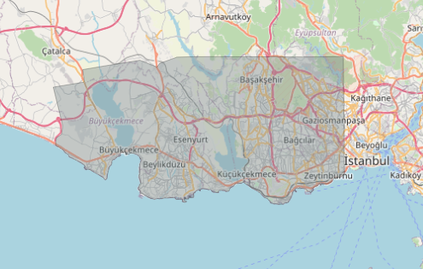

Later, loads of data is downloaded from the Geofabric website and also imported to the QGIS. On the oncoming steps, some methods of processing will be applied on these data.

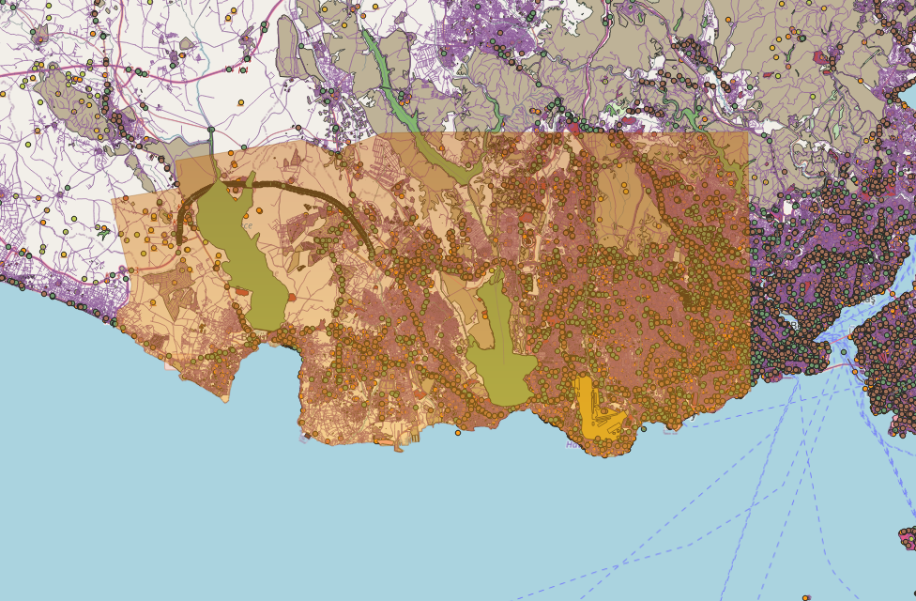

As can be seen, there is lots of data that are dense and out of the boundary. Before clipping the data that are at the out of boundary, some processing steps shall be done as batch processing.

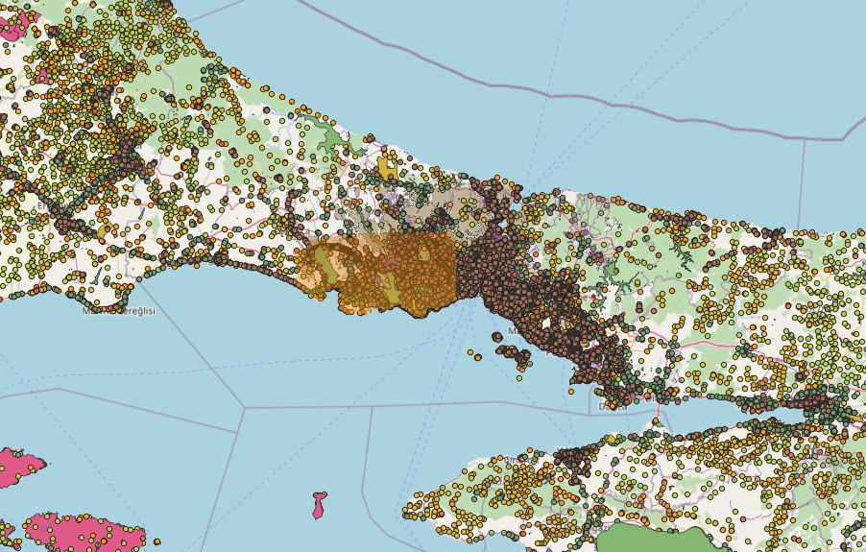

First in the batch processing steps, shapefiles are repaired.

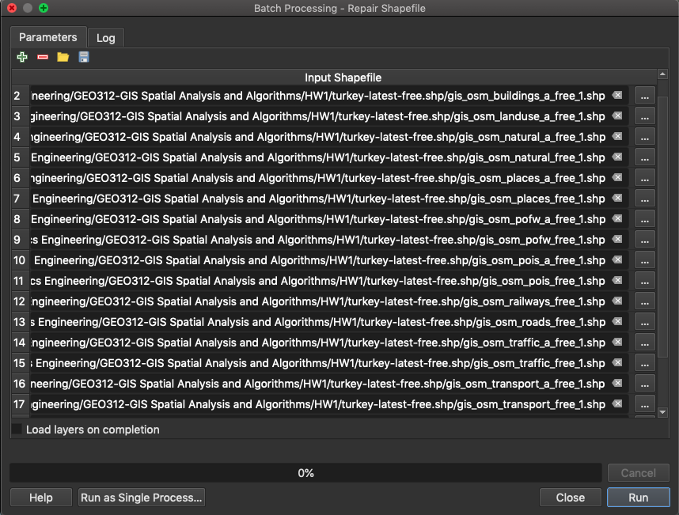

Later, projection of the data and also project, is set with the “Batch Processing – Reproject Layer” tool of QGIS.

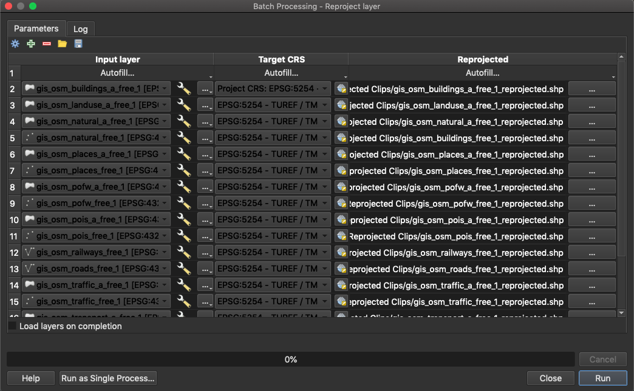

As those steps are done, finally, clip step has become. All out of boundary data will be clipped from the boundary.

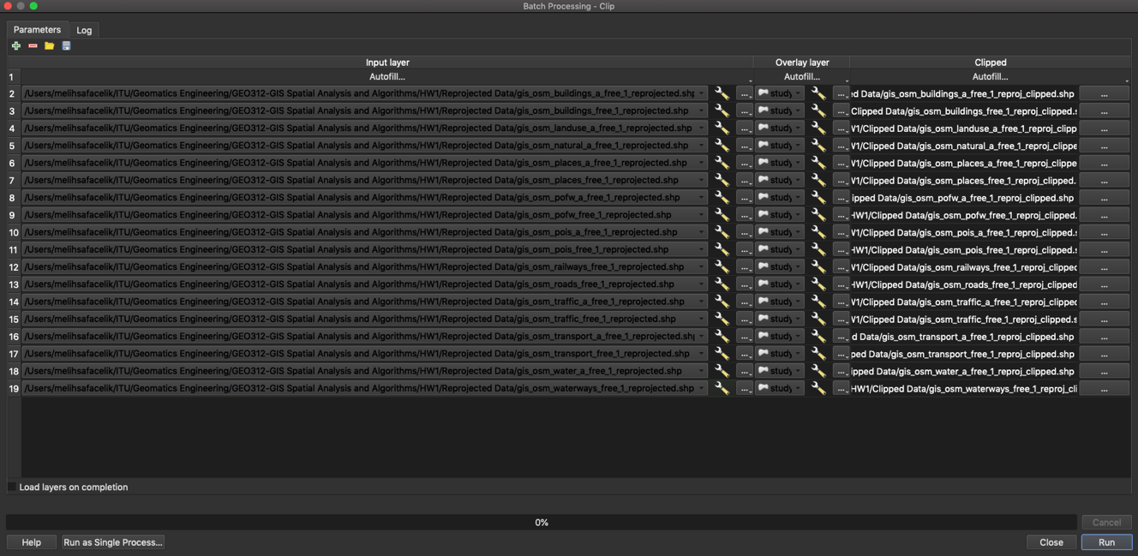

After executing the tool, all out of boundary data is deleted from both on the map and the attribute tables.

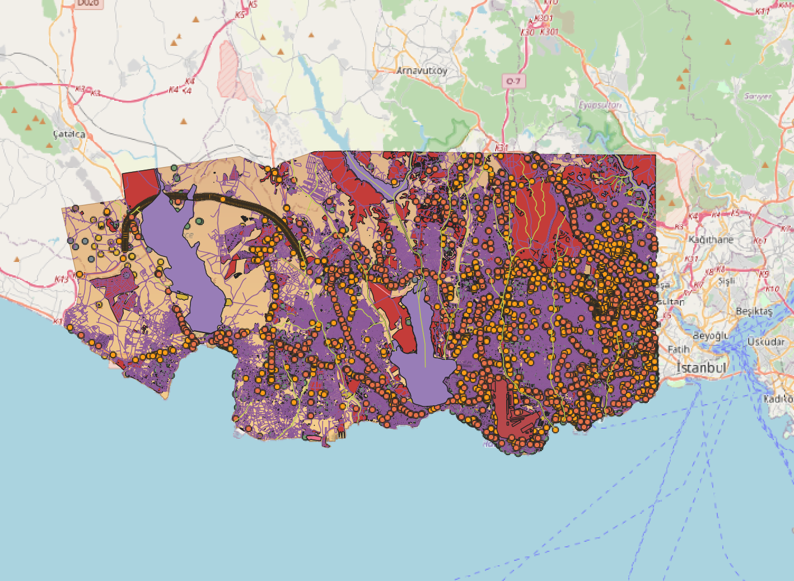

Rasterize process is applied to the waterways and the water bodies class. It can be defined as a vector to raster step.

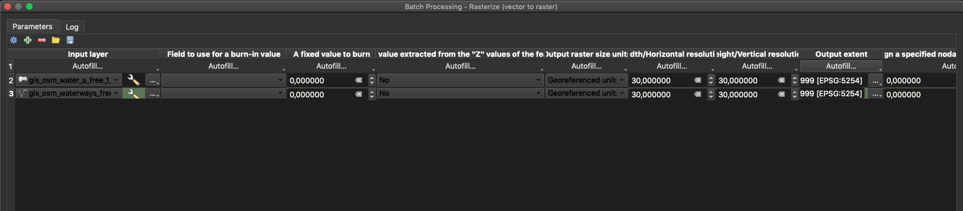

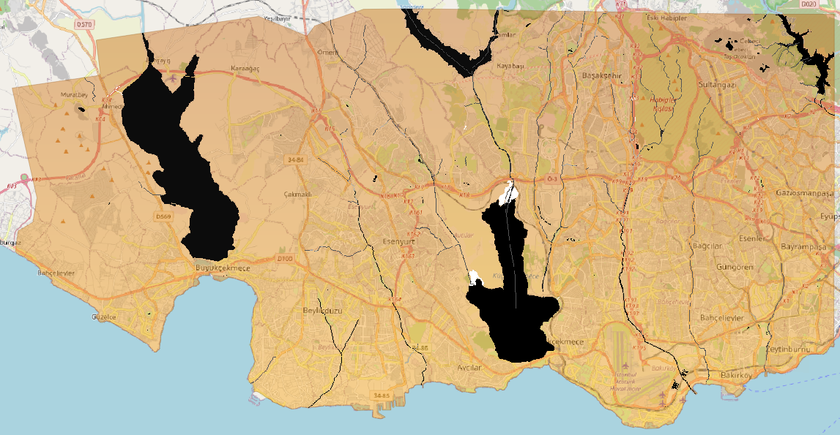

After, proximity step which is called as raster distance too, is applied to the waterways and water bodies products seperately.

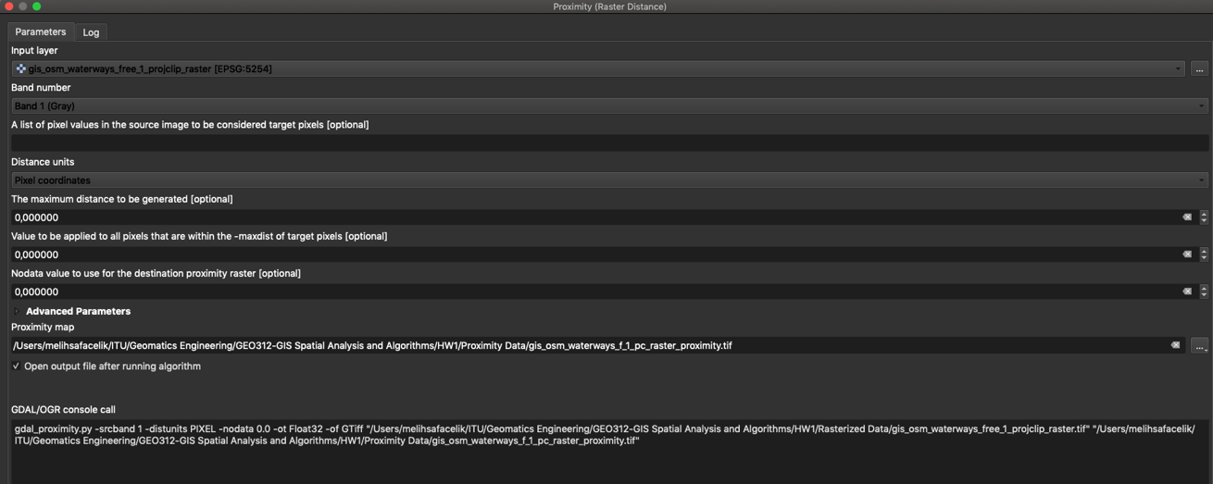

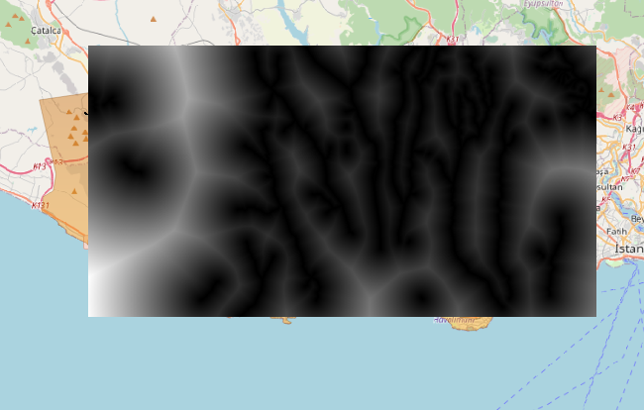

Proximity step result of the water bodies can be seen above. Also, proximity raster of waterways can be found in the project folders. Furthermore, reclassification is done to the water ways and the water bodies data.

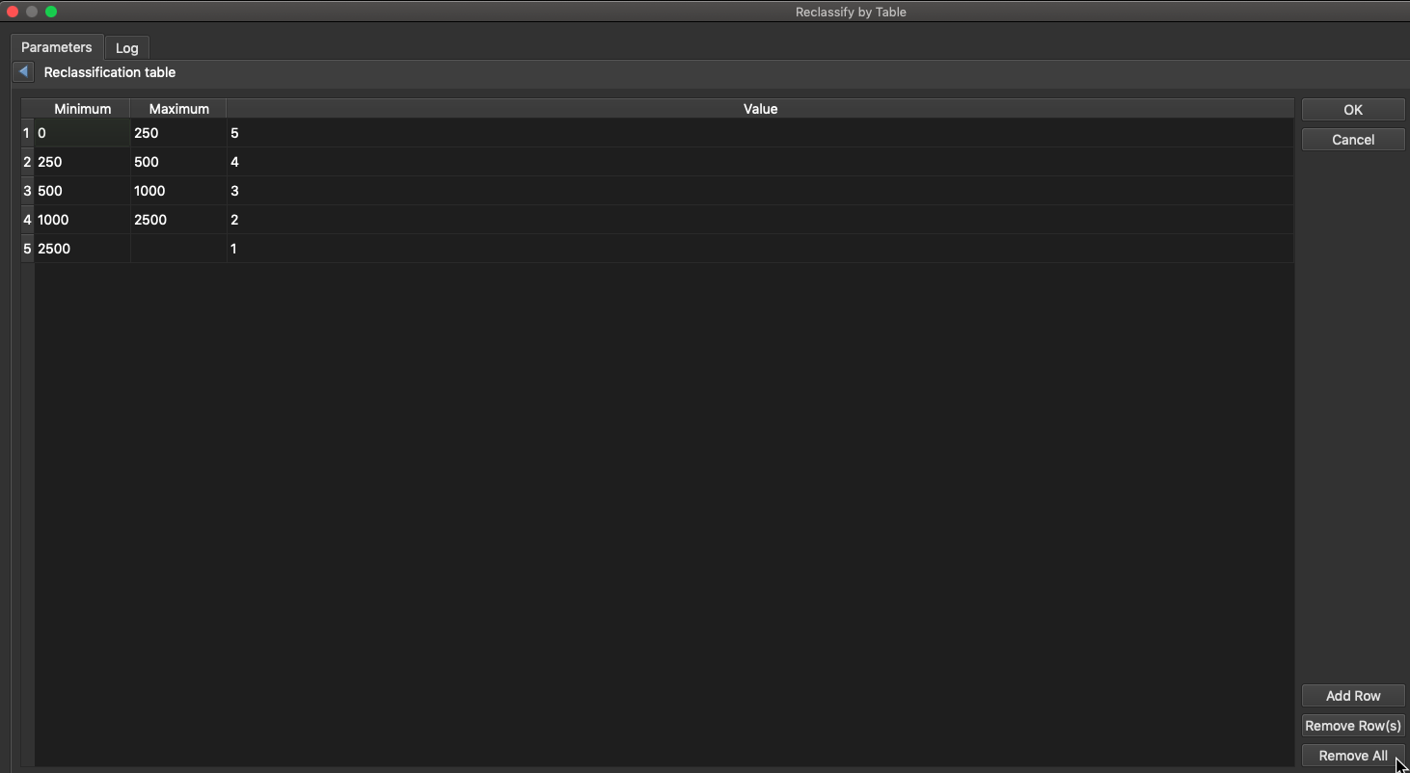

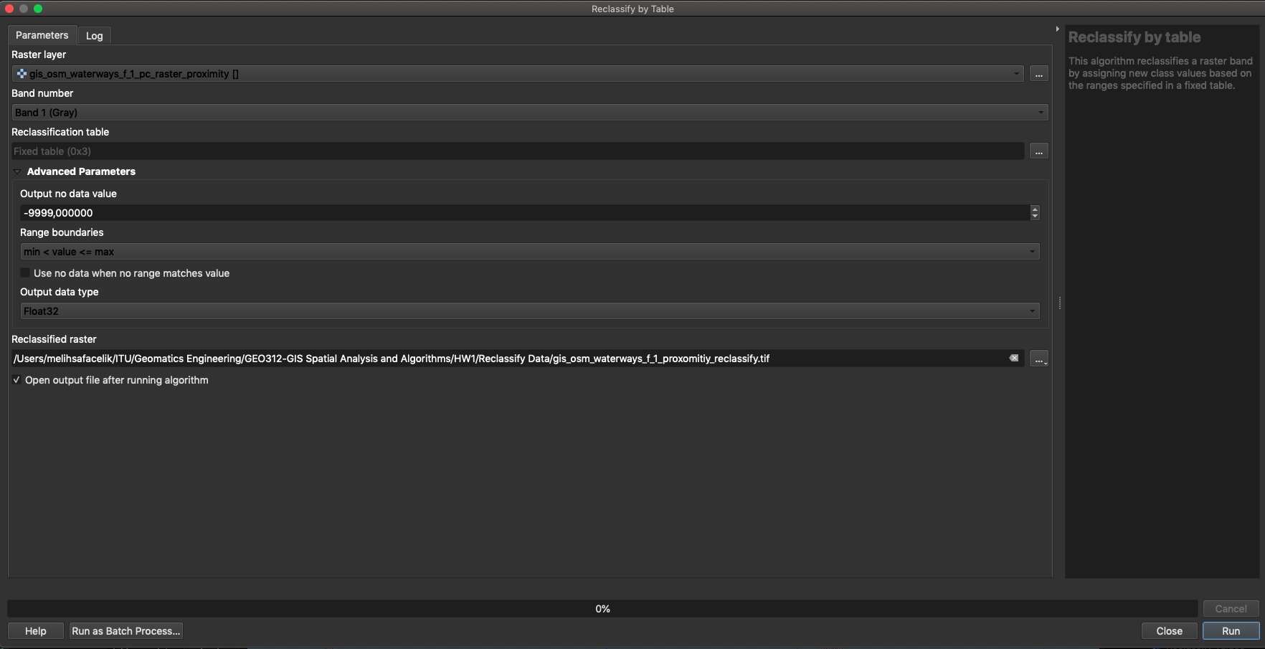

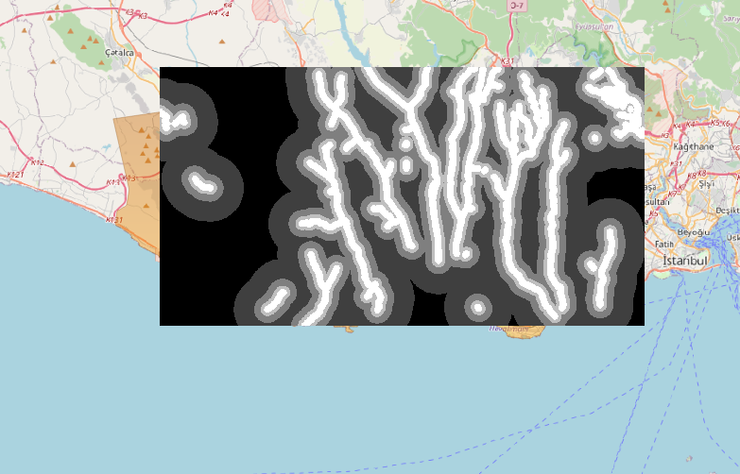

At above, waterways reclassification can be found. At below, reclassification will be applied to the water bodies.

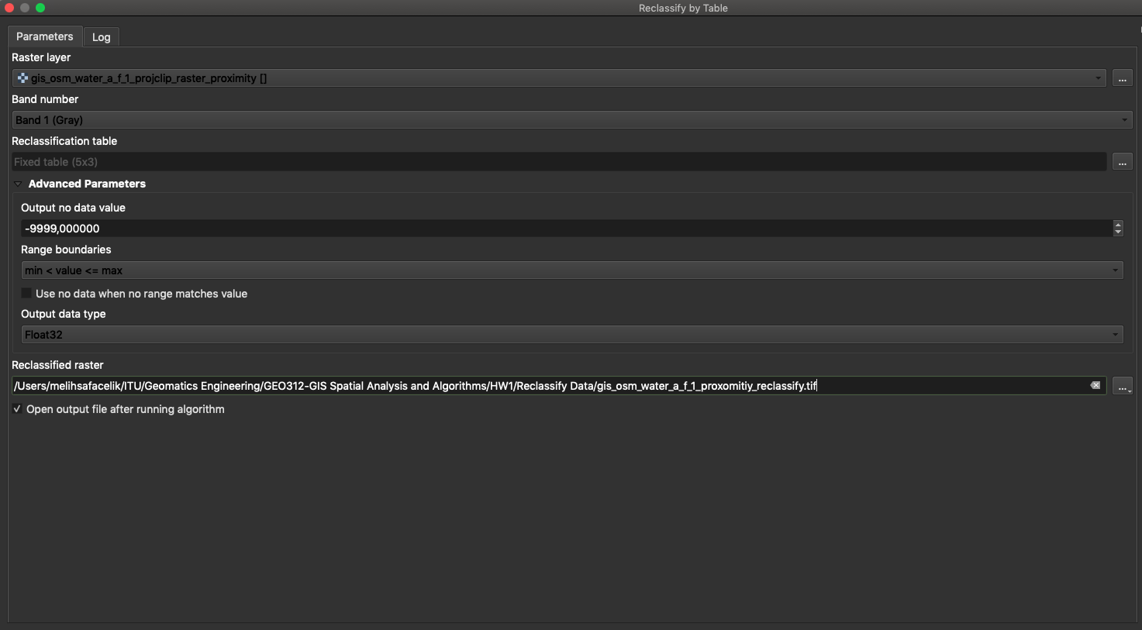

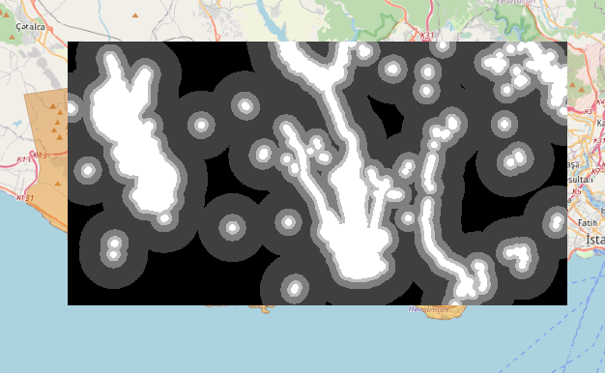

Finally at the above, water bodies reclassification can be found. Moreover on the project, as the next steps, Digital Elevation Model (DEM) data is downloaded from the USGS. Like the previous OSM data, also the out of boundary DEM data is clipped according to the project boundary. Additionally, it is reprojected by warping the DEM data with the QGIS “Warp” tool.

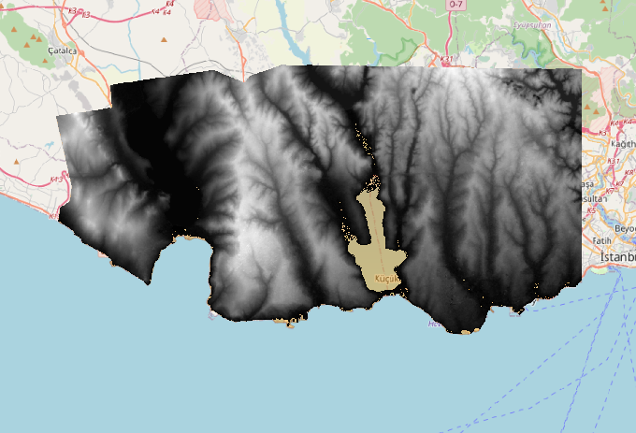

After, DEM data is reclassified according to the given specs which can be found below.

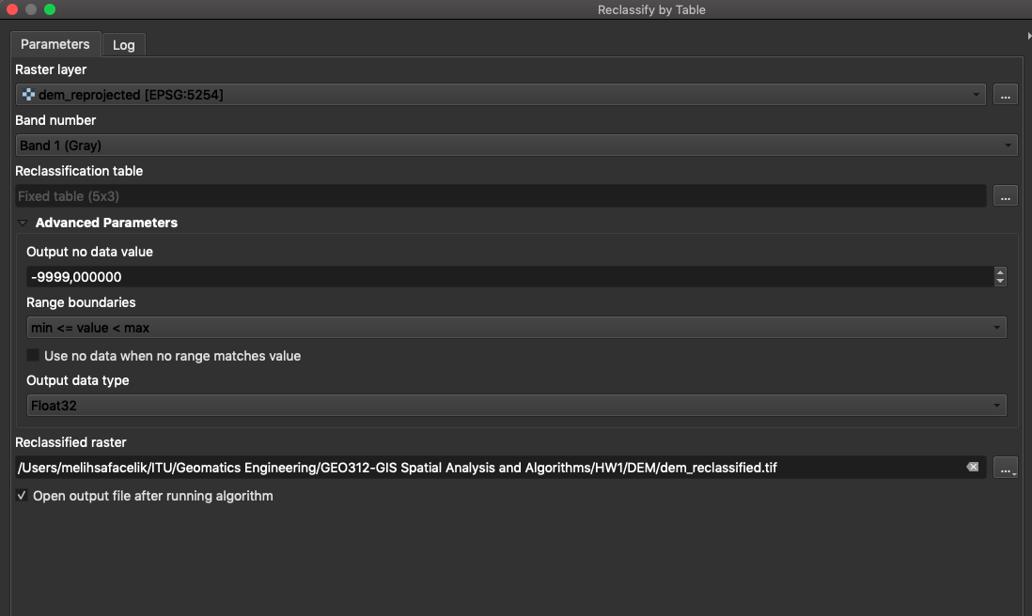

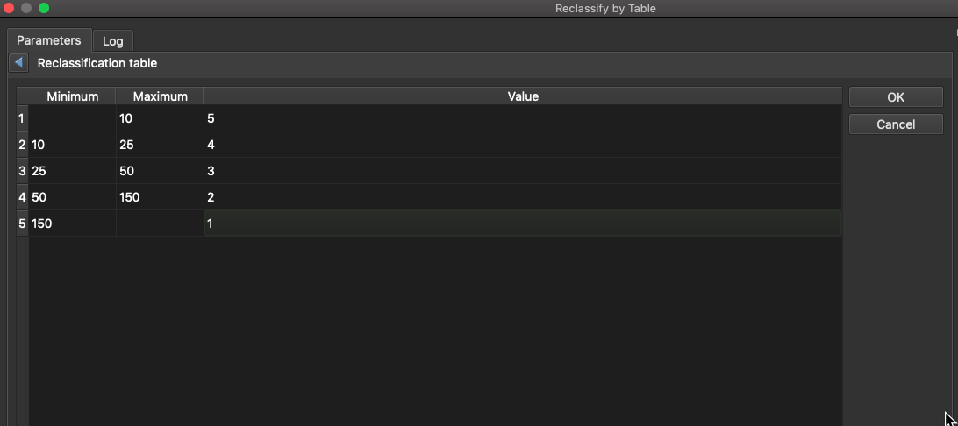

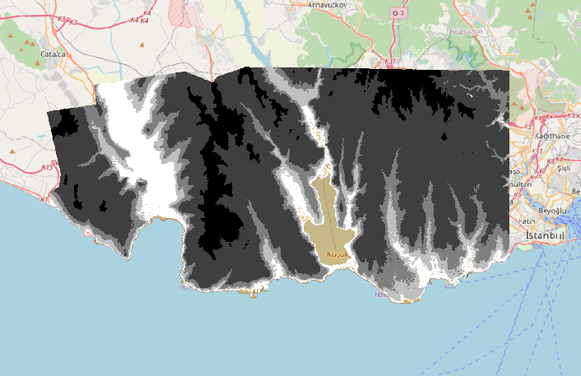

After, 3 data such as water bodies proximity reclassified, waterways proximity reclassified and the DEM reclassified, are considered to do a merge process. In the manner of merging those 3 data, “Raster Calculator” tool is used.

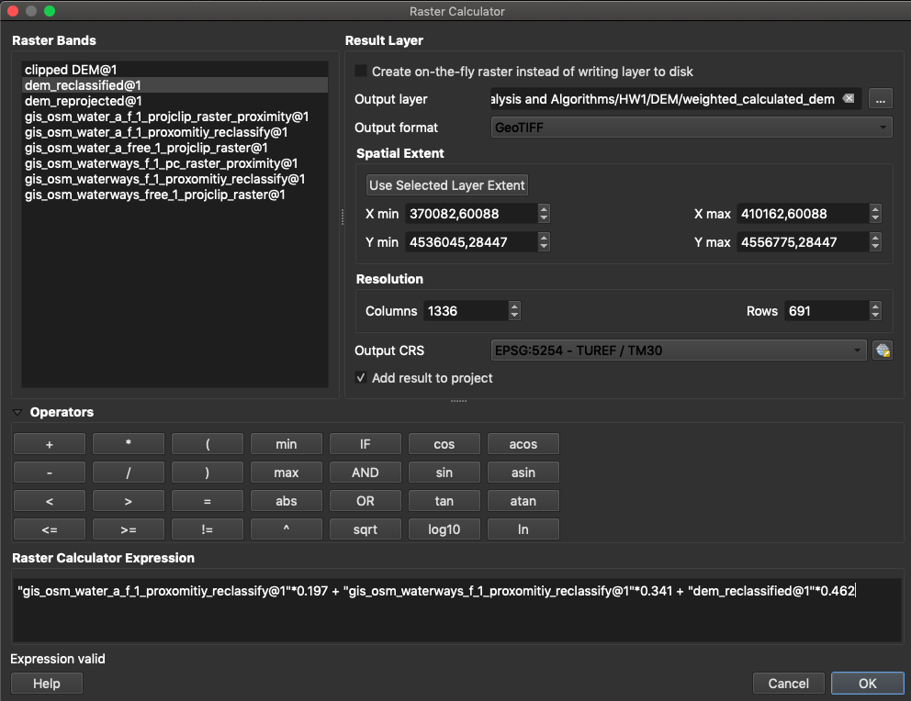

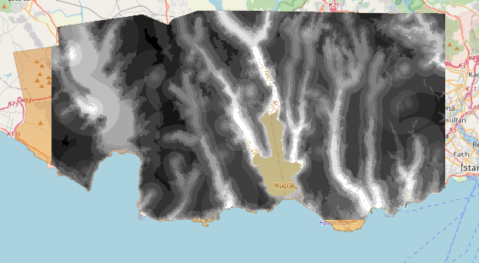

After that, weighted data is reclassified again with the previously given parameters.

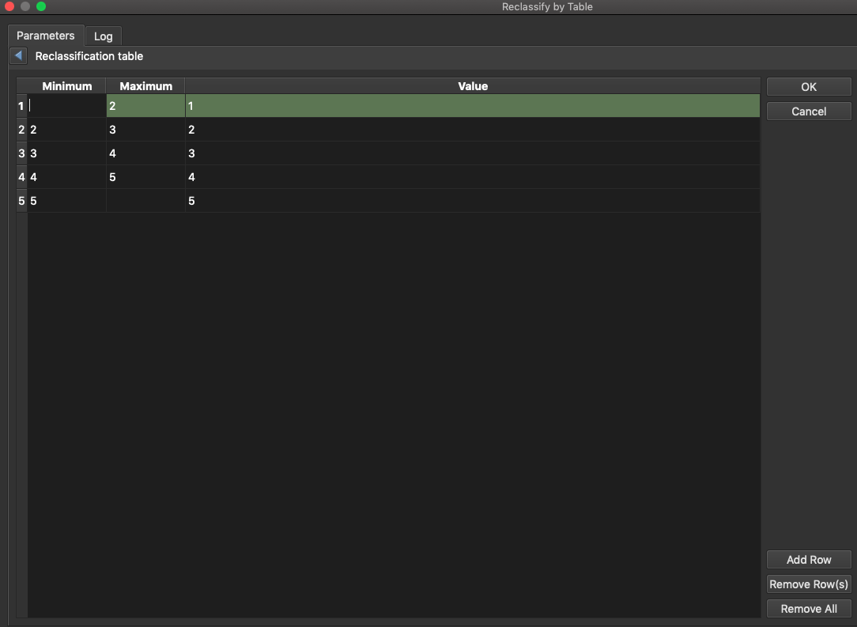 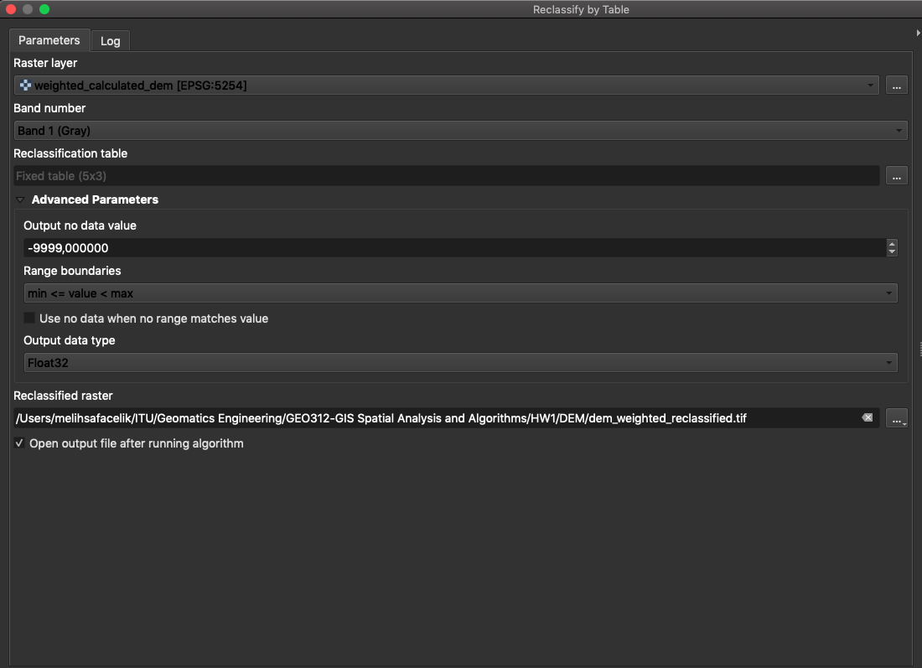

Weighted reclassified DEM image is created.

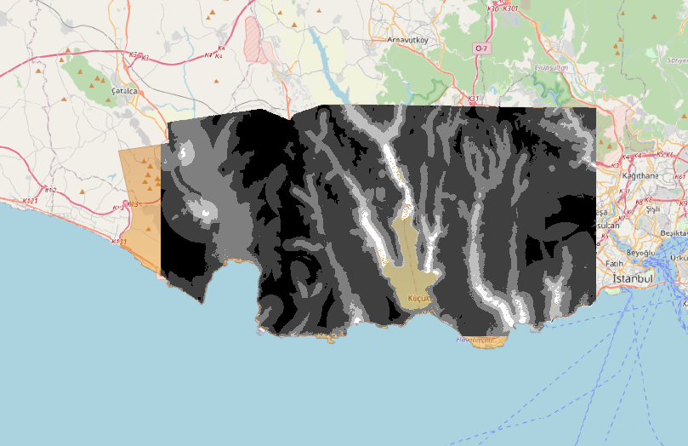

## RESULTS

As the results, output products are created again as maps. These maps can be found as PDF files in the project folder and also will be discussed below.

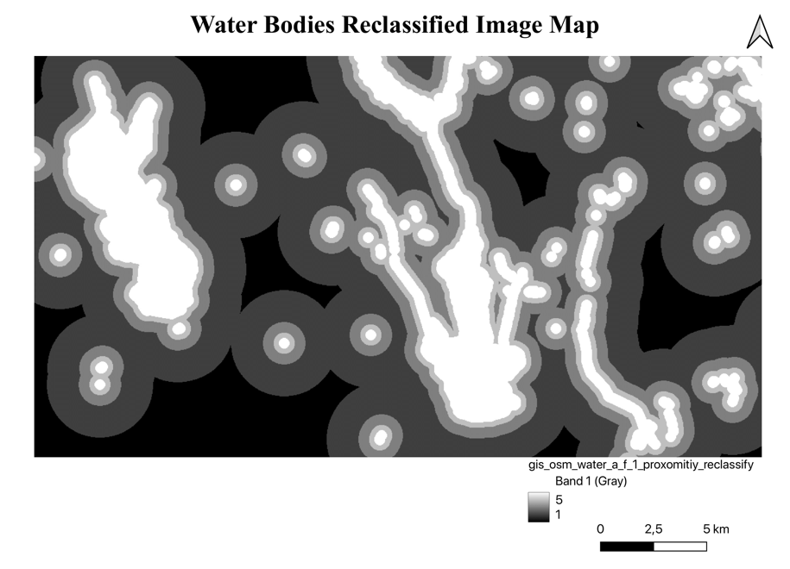

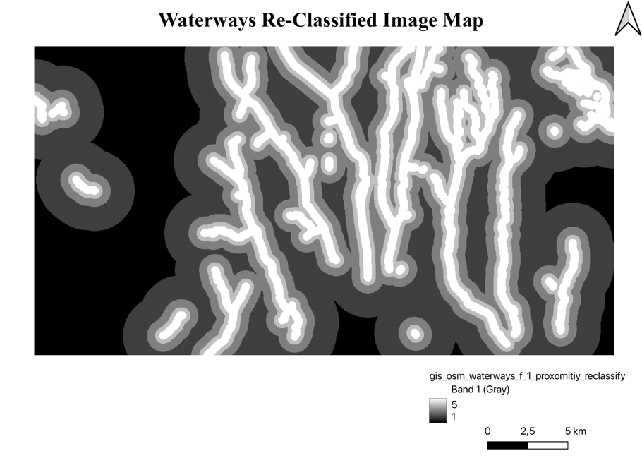

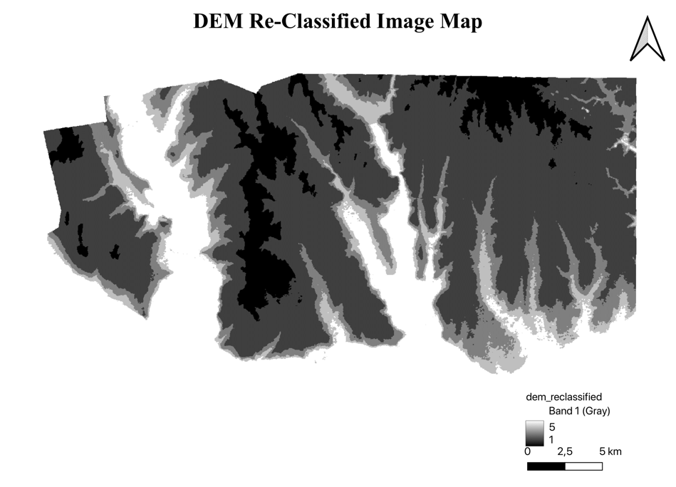

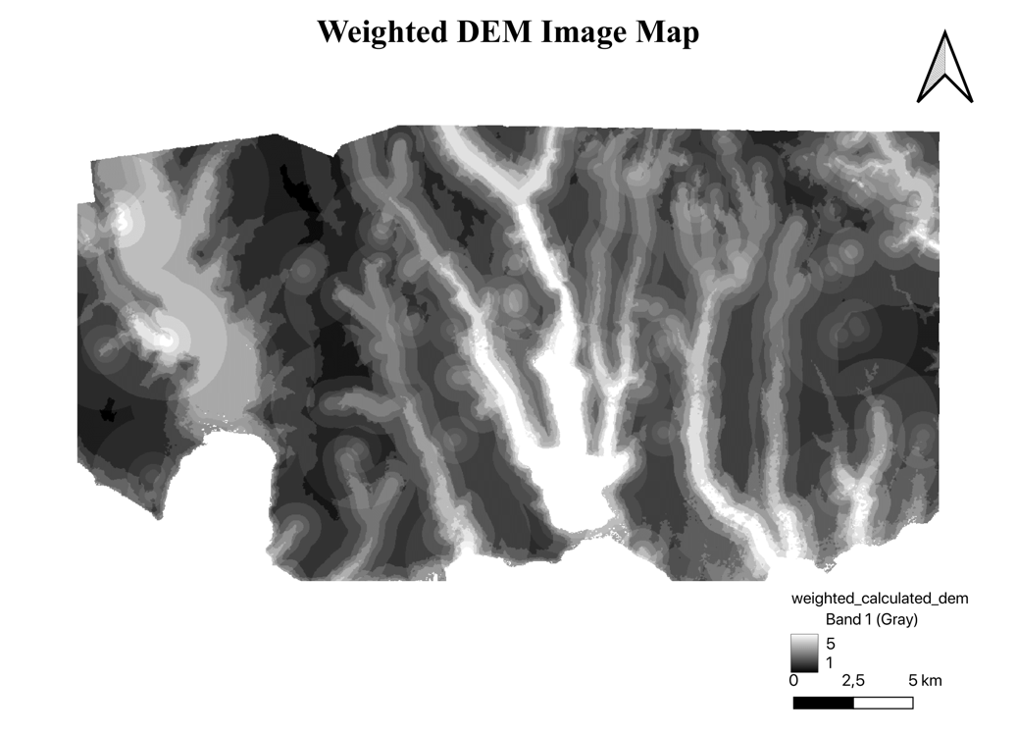

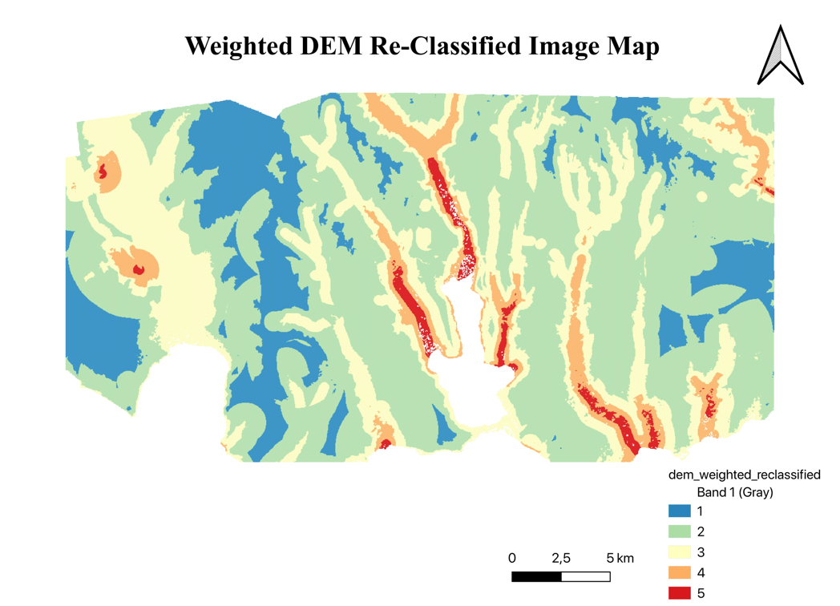

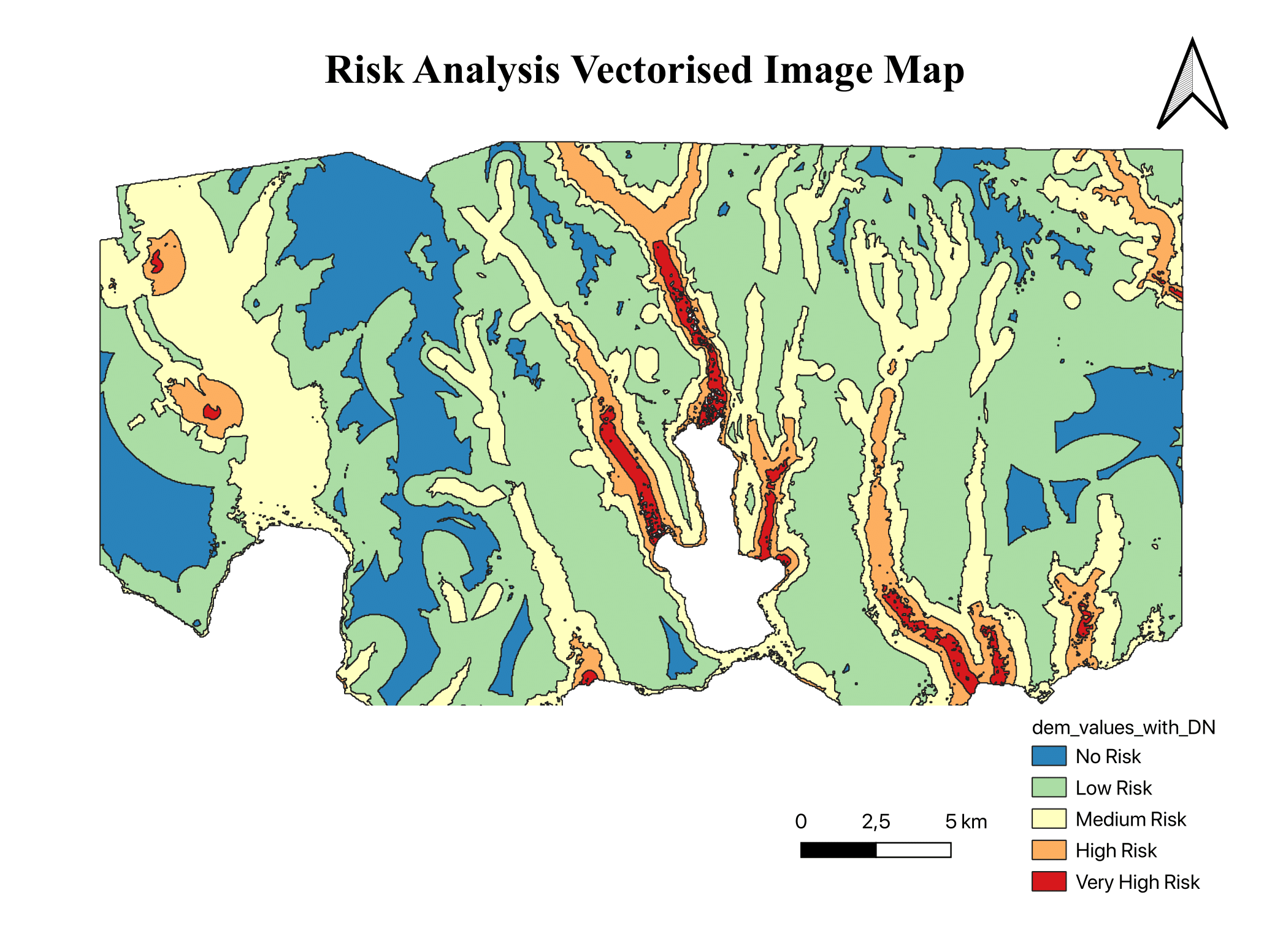

There are 2 query which should be provided and developed by us. Furthermore, these SQL queries are developed in the PostGIS environment and can be seen below. Both of the geopackages of the queries can be found in the project folder.

1. Which schools are located in Medium Risk areas?

SELECT DISTINCT p.name, d.dn

FROM hw1_schema.gis_osm_pois_free_1_reproj_clipped AS p, hw1_schema.dem_values_with_dn AS d

WHERE p.fclass = 'school' AND d.dn = '3';

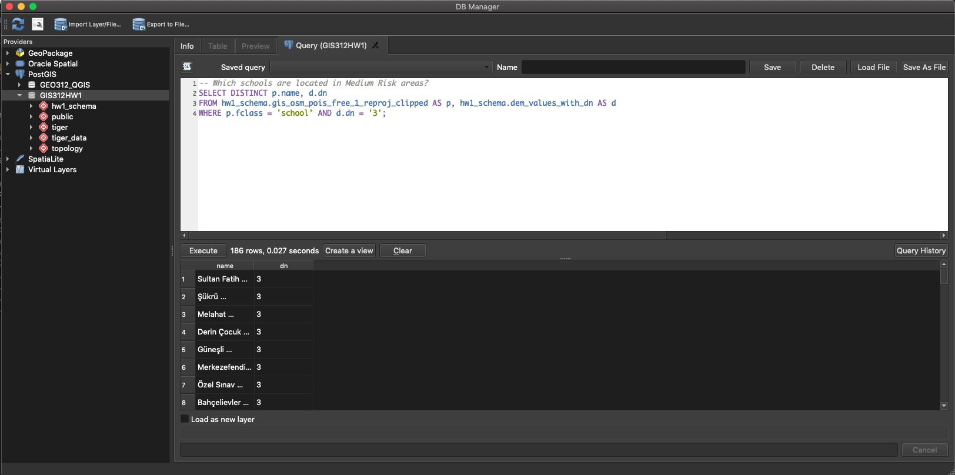

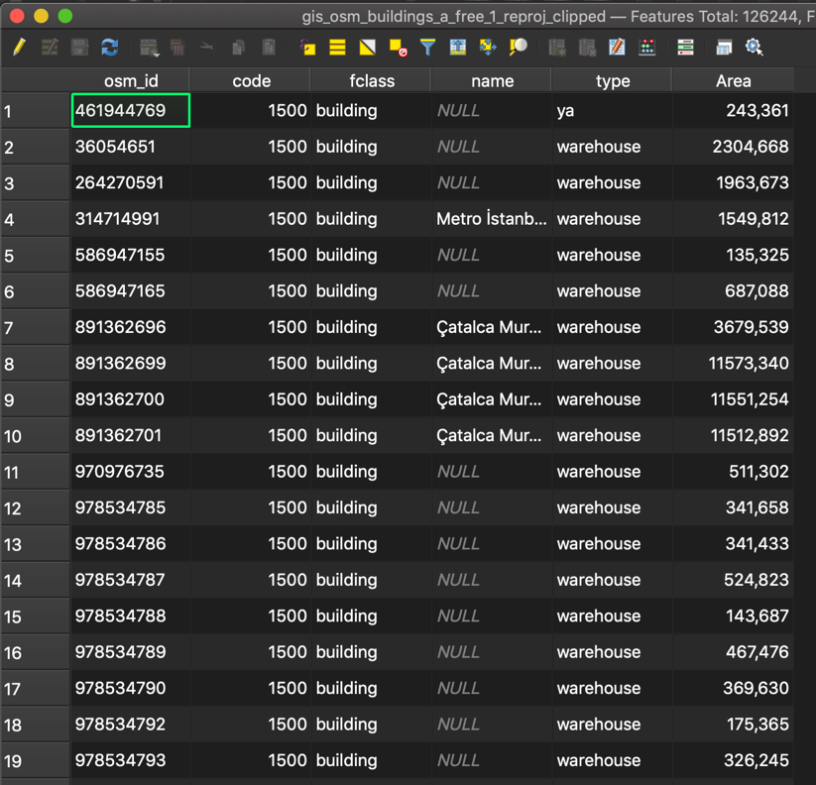

1. What is the total area of residential areas intersected with High-Risk or Very High-Risk areas?

SELECT DISTINCT a.dn, b.type, b.Area

FROM hw1_schema.reclassified_weighted_dn AS a, hw1_schema.gis_osm_buildings_a_free_1_reproj_clipped AS b

WHERE (a.dn = '4' OR a.dn = '5') AND b.type = 'residential';

